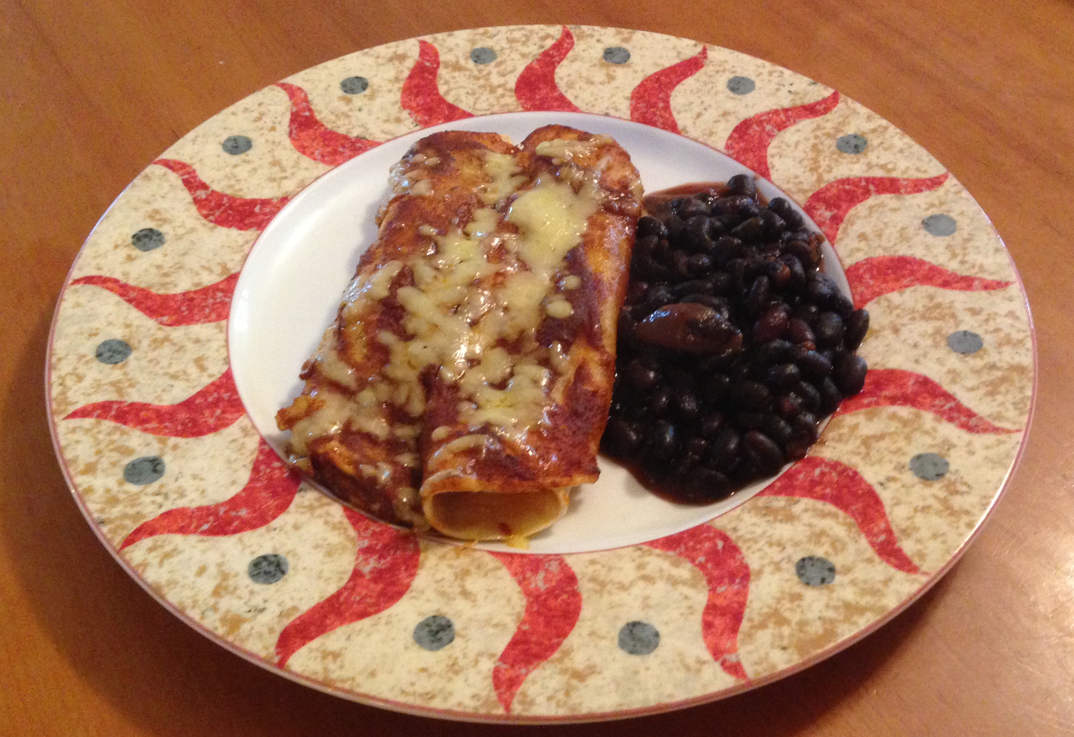
Cheese Enchiladas
with Red Enchilada Sauce
(Makes 12 Enchiladas,
Serves 4)
Sauce: (makes 2 ½ c)
Spice Mixture
¼ c Chili powder
½ t Garlic powder
½ t Sea Salt
½ t Cumin, ground
½ t Oregano (leaf C/S)

3 T veg oil
Spice Mix Available at TSM
1 T flour
2 c. chicken or veggie broth
1-6 oz can tomato paste
½ to 1 c. sour cream (opt for milder)

- Mix Spice Mixture together in a bowl.
- Heat vegetable oil. Add flour.
- Sauté 2-3 minutes until light brown.
- Add spice mixture and cook for 3-4 minutes.
- Add veggie broth and tomato paste. Whisk to remove lumps.
- Reduce heat and simmer to thicken 10-15 min.
- For mild sauce, mix in ½ to 1 c. sour cream.
NOTE: This sauce can be frozen.

To Make into Cheese Enchiladas:

1 lb cheddar (2 @ 8 oz pkg),
12 corn tortillas,
about 3/4 c. vegetable oil
1 med onion, chopped (opt)

- Make Red Enchilada sauce (above). Set oven on at 350º.
- Grate the cheese & set aside 3/4 cup of the cheese to put on top.
- Spray non-stick spray the bottom of a rectangular pan.
- Heat tortillas to soften by frying briefly on both sides in 1 Tbsp of oil.
- After heating each tortilla, fill by spreading 1 - 1½ Tbsp of sauce down the center of each tortilla, then spread 3 tablespoons of cheese over the sauce. If you want onion, sprinkle 1 tsp. of chopped onion. Roll tortilla up and put into pan.
- Repeat for all tortillas, placing them next to each other.
- Pour 1 to 1½ c of the remaining sauce over the top and sprinkle with reserved ¾ c. cheese.
- Bake at 350º for 20-25 minutes.

For Chicken Enchiladas:

Make 3 c. chopped cooked chicken. Mix chicken with ¼ c. salsa. Add ¼ c seasoned chicken to each enchilada and sprinkle with 1½ T of cheese before rolling. Continue with steps 7 and 8 above.

